Semester 2 Examination, 2011
Question/Answer Booklet 

PHYSICS
Stage 2
2011
Name: ___________________________________
Teacher: ___________________________________

Time allowed for this paper
Reading time before commencing work: Ten minutes
Working time for paper: Two and a half hours
Material required/recommended for this paper
To be provided by the supervisor
This Question/Answer Booklet
Physics Formulae, Constants and Data Sheet
To be provided by the candidate
Standard Items: Pens, pencil, eraser, correction fluid, ruler, highlighter
Special Items: MATHOMAT and/or Mathaid, drawing compass, protractor, set square and calculators satisfying the conditions set by the Curriculum Council for this subject.
Important note to candidates
No other items may be taken into the examination room. It is your responsibility to ensure that you do not have any unauthorised notes or other items of a non-personal nature in the examination room. If you have any unauthorised material with you, hand it to the supervisor before reading any further.
Structure of this paper

Section | Number of questions | Suggested Time (minutes) | Number of questions to be answered | Marks available | Percentageof exam
A: Short Answers | 13 | 63 | ALL | 59 | 42
B:Problem Solving | 5 | 70 | ALL | 65 | 46
C: Comprehension and Data Analysis | 1 | 17 | ALL | 16 | 12
 |  |  |  | Total | 100%

Instructions to candidates

- The rules for the conduct of Western Australian external examinations are detailed in the Year 12 Information Handbook 2010. Sitting this examination implies that you agree to abide by these rules.
- Write your answers in this Question/Answer Booklet.
- Working or reasoning should be shown clearly when calculating or estimating answers.
- You must be careful to confine your responses to the specific questions asked and to follow any instructions that are specific to a particular question.
- Spare pages (p29-32) are included at the end of this booklet. They can be used for planning your responses and/or as additional space if required to continue an answer.
Planning: If you use the spare pages for planning, indicate this clearly at the top of the page.
Continuing an answer: If you need to use the space to continue an answer, indicate in the original answer space where the answer is continued, i.e. give the page number.
Fill in the number of the question(s) that you are continuing to answer at the top of the page.
Section One: Short answers 42% (59 Marks)
This section has thirteen (13) questions. Answer all questions. Write your answers in the space provided.
Suggested working time: 63 minutes
_______________________________________________________________________________

1a) Why is there a rule that university research students are never allowed to eat or drink in a Science laboratory where radioactive isotopes are being used? [3 marks]

Eating in the lab could involve the ingestion of contaminants by radioactive materials left
there.
Radioactive materials inside the body are more dangerous as there is direct irradiation of unprotected body cells.
This could lead to mutation of cells and growth of tumours.

b) During an emergency procedure in a Japanese reactor a 70.0 kg man receives α-radiation which causes 105 J of energy to be absorbed by his body over a period of 3 minutes. Calculate the Absorbed Dose the man received during this procedure. [2 marks]

Absorbed dose = = = 1.50 Gy

2. a) A car of mass 1500 kg is at rest when the driver accelerates so that the impulse produced by the engine is 2.00 x 10⁴ N s. What would be the value of the velocity of the car after this initial acceleration? [3 marks]

Impulse = ∆p = m(v-u) = mv
2.00 x 10⁴ = 1500 v
v = 13.3 m s⁻¹

b) Calculate the kinetic energy of the car after the impulse from the engine has been applied. (If you couldn’t do part a) of this question, use a value of 13.0 m s⁻¹ for the car’s velocity) [2 marks]

E_{K} = ½ mv² = ½ x 1500 x 13.3²
E_{K} = 1.33 x 10⁵ J

3.a) When heating a saucepan of water containing 1000 g of water on a gas stove a boy notices that, no matter how high the gas is turned up, the temperature of the water never exceeds 100ºC. Explain why the final temperature remains constant, even though energy is constantly being absorbed. [2 marks]
The energy being absorbed is not going into increasing the kinetic energy of the molecules
or temperature rise but into breaking intermolecular bonds
hence increasing their potential energy i.e. latent heat.

b) Would a solid lump of copper of the same mass (1000 g) take a longer or shorter time to heat up when placed on the same flame of the stove? Explain. [2 marks]
The copper pot would take a shorter time as it has a lower specific heat capacity than water and

4. a) An atom of helium-4 is made up of 2 protons and 2 neutrons in its nucleus. Consider the total mass of these four separate particles and the mass of a helium-4 nucleus and circle the correct answer below.
The mass of the four separate particles, compared with the mass of the nucleus would be:

Greater than the nucleus Less than the nucleus Same as the nucleus
[1 mark]
Answer is Greater than the nucleus

b) Explain your answer to part a). [3 marks]

The mass of the nucleus is less than the sum of its particles because some of the mass has been converted to binding energy.
Binding Energy is used to hold the nucleons together in the nucleus
according to Einstein’s formula E = mc².

5. World champion 200 metre cycle sprinters can develop enormous power in their legs whilst maintaining a top speed of around 78 km h⁻¹.
a) If a 70.0 kg rider maintains a constant force on his bike from his legs of 1.25 x 10² N over the whole 200 m track at a speed of 78 km h⁻¹, calculate a value for the power output of his legs.[2 marks]

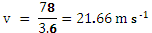

P = Fv = 1.25 x 10² x 21.66 = 2.71 kW

b) Show and label all the forces acting on the cyclist below when moving at a constant velocity. [4 marks]
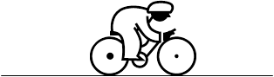
Normal reaction
Weight
Thrust
45º

Air resistance

6. In a game of soccer, a ball travelling at 5.00 m s⁻¹ struck the moving head of a player and rebounded at 6.00 m s⁻¹ into the goal. The angle between the initial and final directions of the ball was 90º.

40º
50º

a) Calculate the resultant of the initial and final velocities of the ball. [3 marks]
Vector triangle drawn

Velocity change is given by
Δv = 7.81 m s⁻¹
tan ϴ = 6/5 so ϴ = 50.2º
OR
tan ϴ = 5/6 so ϴ = 39.8 º
(0.5 mark for magnitude of angle and 0.5 for description of angle)

b) The mass of the ball is 350 g and it was in contact with the player’s head for 200 ms, during which time its change in velocity was 7.50 m s⁻¹. Calculate the magnitude of the force that the ball exerted on the head of the player during contact time. [3 marks]
a = ∆v/∆t = 7.50/0.200 = 37.5 m s⁻²
F = m a = 0.350 x 37.5 = 13.1 N

7a). The elastic of a child’s crossbow is pulled back and held firmly so that it makes an angle of 45.0º with the tail of the arrow. If the tension in each side of the elastic is 65.0 N, (assume a constant value) calculate the total force acting on the arrow and give its direction. [3 marks]

45º
45º

Vector triangle drawn
R = 91.9 N
Direction is straight to the right.

R
65 N
65 N
45º
45º

OR Total force = 2 cos 45 x 65 = 91.9 N straight to the right

b) If the arrow has a mass of 250 g and the acceleration of the arrow by the elastic takes place over a distance of 15.0 cm before leaving the crossbow, calculate the maximum velocity attained by the arrow.(If you couldn’t do part a) of this question, use a value of 90.0 N for net force). [2 marks]

F = ma,

So
a =F/m = 91.9/0.250 = 367.7 m s⁻¹

v² = u² + 2as = 0 + 2 x 367.7 x 0.15 = 110.5

v = 10.5 m s⁻¹

8. Plutonium-94 is an extremely toxic element that would have been present on the Earth’s surface when the Earth was first formed about 4.5 x 10⁹ years ago. Why is it that uranium is fairly abundant on the Earth today but no plutonium can be found? [2 marks]

Uranium 238 has a very long half-life (4.5 x 10⁹ y) but plutonium has a fairly short one.
The Earth is about 4 x 10⁹ years old so a lot of uranium would remain but almost all the plutonium would have decayed.

9. A woman steps out from her car on a warm, sunny day and receives an electric shock from her doorhandle as her foot touches the ground.
a) Explain why this happens. [3 marks]

As warm air moves over the car it becomes charged electrostatically to a high potential.
Rubber tyres prevent leakage of charge through the road to the ground.
When the woman touches the ground and the car body she makes a path to earth, which is at zero potential and a current can flow due to a large potential difference between her and the ground.

b) If the shock is caused by a charge of 300 μC and lasts for a time of 150 ms, what current flowed through the woman’s body in the time she received the shock? [2 marks]

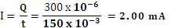

10. A truck driver on the top of a hill releases his hand brake whilst in neutral gear, so that his truck drifts 100 m down the hill to a level road. The hill has is sloped by 25º to the horizontal and the truck’s mass is 6.50 tonnes.
Emergency sand track
25⁰
100 m

a) Calculate the speed of the truck as it reaches the bottom of the hill. [3 marks]

Vertical height of the hill = 100 sin 25 = 42.26 m
Equating E_{P} and E_{K}: mgh = ½ mv²
v² = 2gh = 2 x 9.8 x 42.26 = 828.3
v = 28.8 m s⁻¹
OR
v² ⁼ u² + 2as
v = √ 2as since u = 0
v = √ 2 g sin θ x s = √2 x 9.8 x sin 25 ⁰ x 100
= 28.78 = 28.8 m s⁻¹
When the driver reaches the bottom he realizes that his brakes have failed, but luckily there is an emergency run-off road made of sand which has been made to stop runaway trucks.
b) If the sand has a resistive force of 55.0 kN against the wheels of the truck, calculate the distance the truck travels in the sand before it stops. (If you couldn’t do part a) of this question, use a value of 30 m s⁻¹ for the truck’s velocity). [3 marks]
v = 0, u = 28.78 m s⁻¹
∆E_{K} = ½ x 6500 x 28.78² = 2.692 x 10⁶ J
∆E_{K} = work done against the force, so E_{K} = F x s
2.692 x 10⁶ = 55 x 10³ x s
s = 48.9 m

11. A 12.0 V car battery is used to power the lighting system of a car where the total current being used is 8.50 A.
a) If the car lights are left on for 1½ minutes, what charge is drawn from the battery during this time? [2 marks]
t = 1.5 x 60 = 90 s

q = It = 8.50 x 90 = 765 C

b) Calculate the total power used by the car lights. [2 marks]

P = VI

= 12 x 8.5 = 102 W

12.
1 Ω

1 Ω
2 Ω
A
B
20 V
A₁
A₃
A₂
A₄

The circuit shown is set up with three ammeters inserted to measure the current at different positions in the circuit.
a) State which ammeters would show the same readings of current. [1 mark]

Ammeters A₁, A₂ and A₃ would have the same readings.

b) Explain the logic behind your answer in Part a). [2 marks]

The current through A₁ and A₃ must be the same as they are in series
A₂ must be the same as A₁ as the top and bottom halves of the circuit have the same resistance (2 Ω).

c) Calculate the total current running through the circuit. [2 marks]

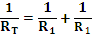 =

so R_{T} = 1 Ω

I_{Total} = I₄ = V/R = 20/1 = 20.0 A

13. A girl at a party gets some ice from the freezer for her glass of Cola. She notices that when she carries the glass into a warm room with lots of people in it, the outside of the glass “steams up” i.e. water droplets condense on the glass. Explain why this “steaming up” occurs. [2 marks]

In the warm party room, the humidity would be high
but when the cold glass is brought into the room, the water vapour in the immediate surrounding condenses on the glass by transferring heat to the water because the cold air around the glass cannot hold as much water vapour.

END OF SECTION 1

THIS PAGE HAS BEEN LEFT BLANK DELIBERATELY

Section Two: Problem-solving 46%(65 Marks)
This section has five (5) questions. Answer all questions. Write your answers in the spaces provided.
Suggested working time: 70 minutes
_______________________________________________________________________________
14. (11 marks total)
A group of Year 11 students is experimenting with a trolley to investigate Newton’s Laws.
They are concerned that friction in the trolley wheels will affect their results, so one student suggests the track they are using can be sloped to compensate for frictional forces present. They push the trolley down the slightly-sloped track and observe its motion using an acceleration sensor linked to a computer. This sends radar waves to monitor the motion of the trolley. The students alter the slope a few times until they are sure that friction can be neglected in their experiment.

Acceleration sensor

a) How will the students know when the degree of slope used has overcome the effects of friction in the wheels? [2 marks]

If the effects of friction have been overcome then net force is zero
and the trolley will start to move at a constant velocity.

They now set up the apparatus, in Experiment 1, as shown below; where a 500 g mass (Mass A) is used as an accelerating force on the trolley running along the sloped track. The acceleration can be read directly off a computer screen attached to the radar acceleration sensor.
a = 4.08 ms⁻²
Acceleration sensor
a = 4.08 m s⁻²
Mass C

Mass B

Start
End
75.0 cm
track
Mass A 500g

b) What was the magnitude of the accelerating force acting on the trolley? [2 marks]

F = mg
= 0.5 x 9.8 = 4.90 N

In Experiment 1 the acceleration of the trolley was recorded as 4.08 m s⁻². In actual fact, the students realise that the accelerating force of mass A is acting on two objects – the trolley and the 500 g mass, itself.
c) Use the value of acceleration given and the information above to calculate the total mass being accelerated, and hence determine the mass of the trolley. [2 marks]

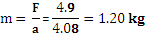

So mass of trolley must be 1.20 – 0.50 = 0.70 kg

For Experiment 2 an extra mass C, 1000 g was added to the trolley and the acceleration of the trolley measured using the same accelerating force as before. Assume that the friction between the track and the trolley remains constant.
d) Calculate the new acceleration of the trolley with mass C added. (If you couldn’t calculate the mass of the trolley alone in part c), use a value of 710 g. [2 marks]

Total trolley mass = 1.00 + 0.70 + 0.5 = 2.20 kg
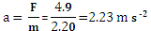

The length of the track over which the trolley is accelerated was 75.0 cm and, for Experiment 1, the acceleration was recorded as 4.08 m s⁻².
e) Calculate a value for the final velocity of the trolley as it reached the end of the track. [3 marks]
u = 0
v² = u² + 2as = 0 + 2 x 4.08 x 0.75 = 6.12
v = 2.47 m s⁻¹

15. (18 marks total)
In an experiment to determine the half-life of the element protactinium a small amount of protactinium nitrate solution was placed in a petridish and the β-particle emission from the liquid was measured using a Geiger Counter.
235.0
Geiger Counter
Petri dish
Particle counter

The Geiger Counter was connected to an electronic particle recorder that displays the total number of counts of β-particles coming from the protactinium source, measured every 25 seconds.
The experimental results are shown below in the table below.
Column A | Column B | Column C | Column D
Time (s) | Total Count | Counts for each 25 s | Count Rate
25 | 233 | 233 | 9.32
50 | 418 | 185 | 7.40
75 | 570 | 152 | 6.08
100 | 687 | 117 | 4.69
125 | 775 | 88 | 3.52
150 | 860 | 85 | 3.40
175 | 933 | 73 | 2.92
200 | 1005 | 72 | 2.88
225 | 1055 | 50 | 2.00
250 | 1123 | 68 | 2.72
275 | 1160 | 37 | 1.48
300 | 1203 | 43 | 1.72
325 | 1241 | 38 | 1.52
350 | 1273 | 32 | 1.28

a)Complete Columns C and D in the table so that Column C shows the counts recorded in each 25 second interval and Column D shows the count rate i.e. the average number of counts over that 25 second interval (the first 4 values have been completed for you). [2 marks]
Deduct 0.5 mark for each wrong answer

b) Using Columns A and D, construct a graph on the grid below. Plot Count Per Second or Rate (y-axis) against Time (x-axis). [5 marks]
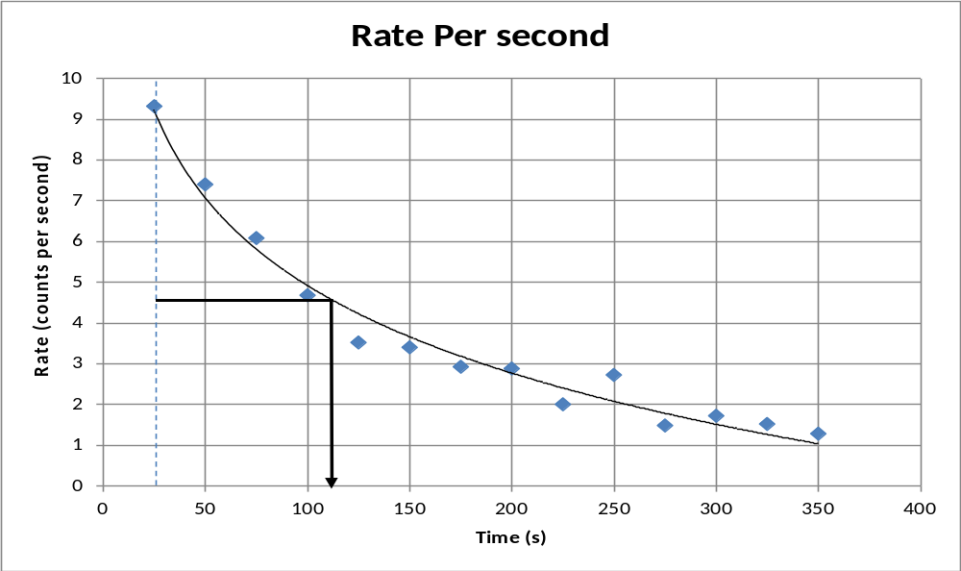
Title
Labelled axes
Scale
Points correct
Line of best fit

c) From the graph, estimate the half-life of protactinium and write your answer below. [2 marks]
Allowing for start at 25 s mark
T_{1/2} = 110 – 25 = 85 s Accept 80 – 90 s
0.5 mark if answer is 110 s
construction lines shown

d) A sample of protactinium nitrate shows a measured activity of 350 Bq at time t = zero. What will its activity be 6 minutes later? (If you do not have an answer for part c) of this question take t_{1/2} to be 80 seconds) [4 marks]

t = 360 s
n, Number of half lives = t / t_{1/2} =
n = 4.24
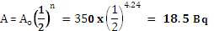
Accept 15.5 to 22.5 Bq
An 85.0 kg scientist experimenting with another long-lived isotope of protactinium accidentally swallows a sample with an activity of 5.00 kBq. The isotope releases 1.60 x 10⁻⁷ J Bq⁻¹ of energy into his body every second.
e) Assuming that the rate of the energy absorbed by the physicist constant and the radioisotope is not eliminated from the body, find how much energy is absorbed per day. [2 marks]
Energy = 5000 x 1.6 x 10⁻⁷ = 8 x 10⁻⁴ J s⁻¹

In 24 hours, E = 24 x 3600 x 8 x 10⁻⁴ = 69.1 J
f) Calculate the dose equivalent the scientist received over 24 hours (in Sieverts, Sv) [3 marks]
Absorbed Dose = 69.1/85 = 0.813 Gy
QF for β = 1
so Effective Dose = 0.813 x 1 = 0.813 Sv
16. (12 marks total)
A glass beaker of mass 150 g contains 250 g water at a temperature of 18ºC and is heated by a Bunsen burner for 2 minutes. At the end of this time the beaker and contents reached a temperature of 79ºC (N.B. specific heat capacity of glass = 840 J kg⁻¹ K⁻¹).
a) By considering the heat absorbed by the beaker and contents, estimate the power output of the Bunsen-burner in watts. [4 marks]

Q = m_{w}C_{w}ΔT + m_{g}C_{g}ΔT
= (0.25 x 4180 x 61) + (0.15 x 840 x 61) = 71,431 J

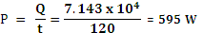
b) Is your estimate of the power of the Bunsen-burner in part a) likely to be higher or lower than the real, total value? Explain. [2 marks]

Calculation would give a lower value than the true one because
some heat would be lost to the tripod and the surroundings so the measured temperature rise would be less than correct. There would appear to be less heat output than the total.

c) The 250 g of heated water from the beaker is then transferred to an insulated cup containing 350 g of water and 50.0 g of ice, both at zero degrees. Calculate the final temperature of the contents of the cup after mixing. [6 marks]

Let final temperature of mixture = T_{f}
Heat lost by hot water = 0.25 x 4180 x (79 - T_{f} ) = 82,555 - 1045T_{f}
Heat gained by ice = (0.05 x 3.34 x 10⁴) + (0.05 x 4180 x T_{f}) = 16,700 + 209T_{f}
Heat gained by cold water = (0.35 x 4180 x T_{f}) = 1463T_{f}
Equating heat gained to Heat lost: 82,555 - 1045T_{f} = 16,700 + 209T_{f} + 1463T_{f}
65855 = 2717T_{f}
T_{f} = 24.2⁰C

17. (11 marks total)
a) Jim has a mass 55.0 kg and jumps down from his garden wall 2.00 m high onto the ground, landing safely by bending his knees. What is Jim’s momentum just before he lands? [3 marks]

Equating E_{P} on the wall to E_{K} at the ground: 55x 9.8 x 2 = ½ x 55x v²
v² = 2 x 9.8 x 2 = 39.2 so v = 6.26 m s⁻¹
Momentum p = mv = 55 x 6.26 = 3.44 x 10² kg m s⁻¹ downwards
OR
v² = u² + 2as
v = √ 2as since u = 0
v = √2 x 9.8 x 2 = 6.261 m s⁻¹
p = mv = 55 x 6.261= 3.44 x 10² kg m s⁻¹ downwards

b) Explain, in terms of physics how, bending his knees makes the force acting on him smaller whilst his momentum change remains the same. [3 marks]

Bending the knees makes the time over which the momentum change occurs longer.
Force on body 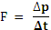 so as t becomes larger F becomes smaller.

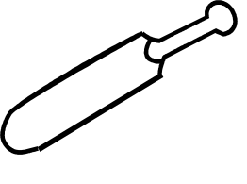
8.50 m s⁻¹
22.5 m s⁻¹
c) Melinda is playing cricket for her school and, in a match, swings her new 2.20 kg bat back to strike a 350 g ball that is being bowled towards her at 22.5 ms⁻¹. Her bat is moving towards the ball at a speed of 8.50 ms⁻¹before it strikes it and the bat slows to a speed of 0.30 m s⁻¹ forwards after the ball is hit.
Calculate the speed with which the ball leaves the bat after it has been hit. [5 marks]

Left negative, right positive

Momentum of the bat + ball before the collision = (2.2 x 8.5) + (0.35 x -22.5)=26.575 kg m s⁻¹

Momentum of the bat + ball after the collision = (2.2 x 0.3) + (0.35v) = 0.66 + 0.35vkg m s⁻¹

Equating: 26.575 = 0.66 + 0.35v

25.915 = 0.35v so v = 74.0 m s⁻¹

18. (13 marks total)
Motor
Belt drive
Paddles
Heater
Fuse 2
Fuse 1
Active
~
Neutral
Earth connection
S₁
S₂

The schematic diagram above is of a washing machine operating on 240 V AC and shows the wiring to the electric motor that rotates the paddles and to an electric heater used to heat the water. The motor and heater both run off the 240 V supply and are protected by fuses 1 and 2.
a) Explain how an AC power supply differs from a DC power supply. [1 mark]

DC is at a constant value so the voltage of one terminal is always + and the other -.
With AC supplies the voltage at one terminal varies between + 240 and -240 volts many times per second.

b) If the electric motor has a power rating of 1800 W, what is the minimum value of current that should be used for fuse 2 in this circuit? [2 marks]

P = VI so 1800 = 240 I
I = 7.50 A
c) In one minute the paddles do work in agitating the clothes and water equivalent to 98.5 kJ. Calculate the efficiency of the electric motor. [3 marks]

Energy used by the motor in one minute = Pt = 1800 x 60 = 108,000 J
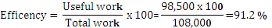
OR
Efficiency = (power output)/(power input) x 100 = (98500/60)/(1800) x 100 = 91.2 %

d) The outside metal cases of all washing machines are connected to Earth by a wire. Explain why the earth wire is used. [3 marks]

If an active wire breaks inside and touches the metal case, it will become electrified.
If a person touches the case the potential difference between their hand and feet = 240 V, giving them a shock.
With an earth wire attached to zero potential, the case potential can never rise above zero and has lower resistance than the human body so the electrical energy flows through earth wire.

The water heater in the machine is rated at 2.25 kW.
e) If there is 5.50 kg of water in the tub at a temperature of 18.0ºC, how long would it take in minutes for the heater to raise the water to 60.0ºC? [4 marks]

E = Q = P x t = 2250 x t
Q absorbed by the water = m c ΔT = 5.50 x 4180 x 42 = 965,580 J
Equating: 2250 x t = 965,580
So time t = 429 s or 7.15 minutes.

END OF SECTION 2

Section Three: Comprehension 12% (16 Marks)
This section contains one (1) question. You must answer this question. Write your answers in the spaces provided.
Suggested working time: 17 minutes.
_______________________________________________________________________________
19. Electric shocks
Paragraph 1
Death caused by an electric shock is called electrocution. There were 550 electrocutions in the US in 1993, which translates to 2.1 deaths per million inhabitants.
Paragraph 2
The minimum current a human can feel depends on the current type (AC or DC) and frequency. A person can feel at least 1 mA of AC at 50 Hz, while at least 5 mA for DC. The current may, if it is high enough, cause tissue damage or fibrillation (rapid irregular heartbeat) which leads to cardiac failure. 60 mA of AC at 50 Hz or 300–500 mA of DC can cause fibrillation. If not immediately treated by defibrillation machines, fibrillations are usually lethal because all the heart muscle cells move independently instead of in the coordinated pulses needed to pump blood.
Paragraph 3
If the voltage is less than 200 V, then the human skin is the main contributor to the resistance of the body in the case of a macroshock—the passing of current between two contact points on the skin. The resistance characteristics of the skin are non-linear however. If the voltage is above 450–600 V, then molecular breakdown of the skin occurs. The protection offered by the skin is lowered by perspiration, and this is accelerated if electricity causes muscles to contract above the “Let-go threshold” for a sustained period of time.
Paragraph 4
If an electrical circuit is established by electrodes introduced into the body (e.g. probes attached to internal organs) then the potential for lethality is much higher if a circuit through the heart is established. This is known as a microshock and currents of only 10 µA can be sufficient to cause fibrillation in this case. This is a concern in modern hospital settings when the patient is connected to multiple devices.
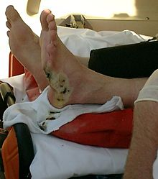
Burns
Paragraph 5
It is a relatively unknown fact that more electrical workers die from burns than from an electric shock. In fact, only around 20% of deaths are the result of electric shock itself. Voltage levels of 500 to 1000 volts tend to cause internal burns due to the large amount of energy produced.
The heat produced may cause severe burns, especially on unprotected flesh. The blast energy produced by vaporizing metallic components can break bones and irreparably damage internal organs
Second-degree burn after a high tension line accident

The formula for this burn energy is 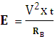 where:
v = applied voltage
t = time of exposure
R = body resistance
Neurological effects
Paragraph 6
Current can cause interference with nervous control, especially over the heart and lungs. Police forces now use the"Taser", which fires projectiles that administer the shock through a thin, flexible wire and incapacitates the nervous system without permanent damage.
Body resistance
Paragraph 7
The voltage necessary for electrocution of a person depends on the current through the body and the duration of the current. Ohm's law states that the current drawn depends on the resistance of the body. The resistance of human skin varies from person to person but in dry conditions, the resistance offered by the human body may be as high as 100,000 ohms. Wet or broken skin may drop the body's resistance to 1,000 ohms and high voltage electrical energy quickly breaks down human skin and may reducethe human body's resistance to 500 ohms.
Paragraph 8
The International Electro Technical Commission gives the following values for the total body resistance of a hand to hand circuit for dry skin. Table 1 shows how average Total Body Resistance varies with voltage for an average of 95% of the population.

Shock Voltage (V_{S})  Table 1 | Body Resistance R_{B} (k Ω)
25 | 6.1
100 | 3.2
220 | 2.125
1000 | 1.5

a) Which seems to be more hazardous to humans when receiving an electric shock, an alternating or a direct current? Explain your answer. [2 marks]

AC seems more dangerous according to paragraph 2
where it mentions that heart fibrillation occurs at 60 mA for AC but a much larger current is needed with DC (300 – 500 mA).

b) Why is it that hospital patients are particularly susceptible to electrocution from smaller voltages than normal? [2 marks]

Paragraph 4 mentions that in hospital a person’s heart may be linked directly to electrodes which may pick up a small stray (induced) current.
This only needs to pass through a small thickness of flesh compared with whole body electrocution, so the resistance would be very low and can lead to muscle burn-out with a tiny voltage. Only 10 μA is needed when passing straight through the heart.

c) Use Table 1 and other data from this article to calculate the burn energy received by a victim who touches a 1000 V high tension cable for a time of 100 ms. [3 marks]

At 1000 V, R_{B} = 1500 Ω.
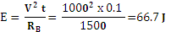

d) In Paragraph 3 it mentions that “The resistance characteristics of the skin are non-linear however”. What evidence can you give in this article to support this statement? [2 marks]

Looking at Table 1 it can be seen that the resistance is not directly proportional to voltage.

The variable seem to be related in an inverse way – but not directly

e) From the data in Table 1 it is obvious that Body Resistance R_{B} is not directly proportional mathematically to the Shock Voltage V_{S}. However, a research medical physicist has a hypothesis that R_{B} is related to V_{S} by the formula: 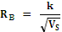where k is a constant.
Complete Table 2 below by inserting values into the blank, right-hand column. [2 marks]
Shock Voltage (V_{S}) | Body Resistance R_{B} (Ω) | Reciprocal of root V_{s,} (Volt ^{-1/2})
25 | 6,100 | 0.2
100 | 3,200 | 0.1
220 | 2,125 | 0.07
1000 | 1,500 | 0.03
Table 2

0.5 mark each correct answer
f) Plot a graph on the paper below of R_{B} (y-axis) versus (x-axis) [3 marks]

Graph marks:
Correct scale
Points correct
Line of best fit

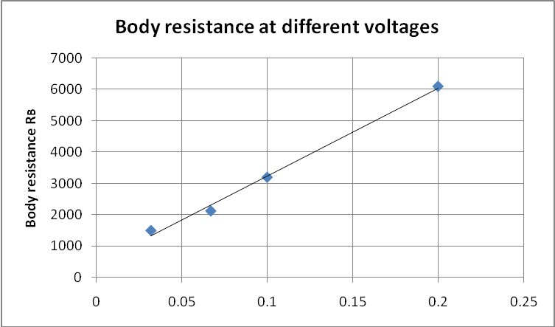

g) Use the graph to provide evidence as to whether the physicist’s hypothesis might be correct. [2 marks]

Graph shows quite a good linear relationship between R_{B} and

so the hypothesis seems correct i.e. the points form a good line of best fit.

End of Exam

Additional working space
Additional working space
Additional working space

